**Project Design Phase-II**

**Data Flow Diagram & User Stories**

|  |  |
| --- | --- |
| Team ID | PNT2022TMID42240 |
| Project name | Personal assistance for senior citizens who are self reliant |
| Maximum marks | 4 Marks |

DATA FLOW DIAGRAM:

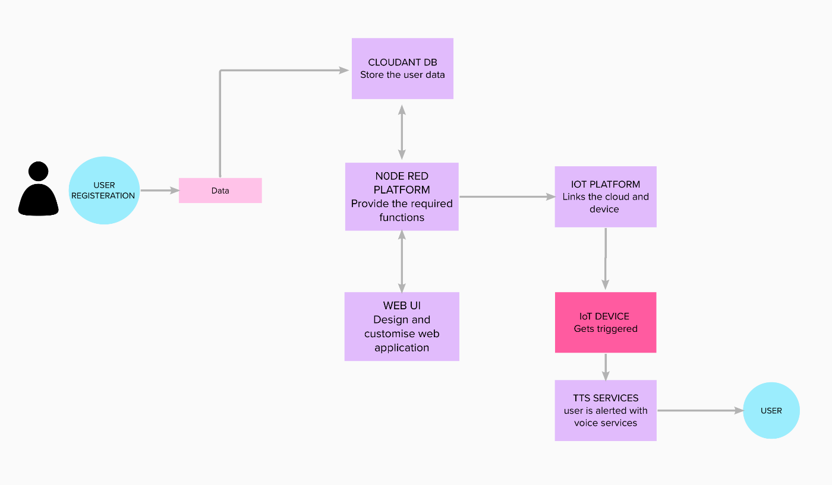

USER STORIES

Use the below template to list all the user stories for the product.

|  |  |  |  |  |  |  |
| --- | --- | --- | --- | --- | --- | --- |
| **User Type** | **Functional Requirement (Epic)** | **User Story Number** | **User Story / Task** | **Acceptance criteria** | **Priority** | **Release** |
| Customer (Mobile user) | Registration | USN-1 | As a user, I can register for the application by entering my email, password, and confirming my password. | I can access my account / dashboard | High | Sprint-1 |
|  |  | USN-1 | As a user, I will receive confirmation email once I have registered for the application | I can receive confirmation email & click confirm | High | Sprint-1 |
|  |  | USN-2 | As a user, I can register for the application through form. | I can register by new account | Medium | Sprint-1 |
|  | Login | USN-1,2 | As a user, I can log into the application by entering email & password | I can able to view dashboard | High | Sprint-1 |
|  | Dashboard | USN-1,2 | In the dashboard section, the user able to see the medicines and their timing schedule and also see the progress. | I can access the data | High | Sprint-2 |
| Customer (Web user) | Login | USN-3 | As a customer, I can register and access the application through app URL | can access my account | High | Sprint-2 |
| Customer Care Executive | Dashboard | USN-4 | As a customer care executive, I can login and check the status | I can login into the user account by user confirmation | Medium | Sprint-2 |
| Administrator | Login | USN-5 | As an Administrator, I can login into many user accounts and have control over them | I can login into user account | High | Sprint-1 |
|  | Dashboard | USN-5 | As an Administrator, I can access the user’s database | I can access the user accounts and data | Medium | Sprint-2 |